Date: January 5, 2023
To: FHWA, NCUTCD Technical Committees, NCUTCD Pedestrian Joint Task Force

From: Michael Williams
Re: A Survey of Signs and Pavement Markings on Existing U.S. Edge Lane Roads (ELRs)

Uncertainty around the pavement markings and signs that should be required or recommended for the edge lane road treatment prompted a survey of current use in the U.S. This memo contains information on the known ELR facilities in the U.S, survey background, and the results of the survey.

The term “edge lane road” or ELR is used in this memo and includes facilities known as advisory bike lanes and advisory shoulders. An ELR is the same treatment as these other two. The ELR name is independent of the type of road user being supported and avoids the problems with the other terms.

ELRs in the U.S.
I maintain a database of ELRs, their characteristics, and agency contact information. I have verified 80 installed U.S. ELRs and am aware of another 3 whose implementation status is unclear. Approximately 2/3 of U.S. ELRs are installed without FHWA approval. A comprehensive survey of U.S. current practice is not possible with FHWA records alone.

Despite the December 2021 announcement that the FHWA was limiting or ceasing approval of requests to experiment with this treatment, ELR use has continued to grow. Release of the AASHTO Bike Guide will increase awareness of the treatment and likely spur greater use.

Note: Shortly before finishing this memo, one responding agency related that they had converted two of their ELRs to a different treatment but had recently installed two more, keeping their total unchanged. Given this, the number of verified installations is really 82. This report, including the graph above, uses 80 throughout.

Survey Process
From November 2023 to January 2024, a survey of ELR-using agencies in the U.S. was conducted. The survey included questions on signs, markings, and beliefs about those devices. Some flaws were found in the questions. Discovered flaws are noted in this report.

The survey was advertised via multiple posts on LinkedIn, Twitter (X), the ELR email listserv, on the APBP email listserv, the ITE email listserv, and via direct emails to representatives of agencies known to have installed an ELR.

The qualifications for participation were that the facility be located in the U.S. and be currently installed. ELR variants are not included in the survey due to the problems associated with a survey of signs and markings being applied to facilities which use fundamentally different designs, markings, etc. These variants include: “half-ELRs” which place one direction of VRU traffic in the vehicular travel lane (usually with shared lane markings) and the other direction in an edge lane, ELRs with centerlines, and ELRs with non-standard markings e.g. a solid line to demarcate the edge lanes. The number of variants in the U.S. is known to be greater than four and believed to be less than ten.

The survey instrument, responses, and this report are all available at https://www.edgelaneroads.com/2023-elr-survey.html. Not all questions and responses from the survey are included in this report. Full information is available in the survey instrument and responses files. The survey responses have been anonymized.

The survey is facility-based; each facility generates one survey response. Review of the survey results showed that every agency with multiple facilities answered most questions the same way (with some exceptions in the signage section). Because a number of responding agencies have multiple ELRs, some agencies could be overrepresented in the results. Results are listed with both the number of facilities and the number of agencies to mitigate that effect.

Most U.S. ELRs are intended only to support bicyclists; fewer were installed to support shared use and only a small number were installed primarily to support pedestrians. The intended user type of each facility was not investigated in this survey. This information should be gathered in future surveys.

Time constraints allowed only for textual presentation of the data. Time constraints also precluded investigation into relationships between answers, e.g. “Did agencies that used no signage always use symbols in the edge lane?”

Results

Survey Population Characteristics
Number of verified ELR installations in the U.S.: 80
Number of ELRs removed: 4
Number of existing, verified ELRs in the U.S.: 80 - 4 = 76 (survey population)

Of the 76 possible survey participants:
Number of ELRs with FHWA Approval: 27 (36%)
Number of ELRs without FHWA Approval: 50 (66%)
Number of ELRs with unknown FHWA Approval status: 4 (5%)

Number of agencies responding: 20
Number of facilities included in the survey: 50 (66% of the survey population)

Nineteen (38%) of the survey responses concerned FHWA-approved ELRs. This is slightly more than the 36% of ELRs with FHWA approval in the survey population. There is a small overrepresentation of FHWA approved ELRs in the survey.

Survey Responses
Both the number of facilities and number of agencies corresponding to each response are provided. This information mitigates the overrepresentation of multi-ELR agencies when responses are evaluated on a per-facility basis.
The survey responses are organized into 3 sections: Safety, Signs, and Pavement Markings.

SAFETY
Safety of the ELR treatment continues to be the most common concern raised. Most of this concern focuses on the possibility of head-on crashes between approaching motor vehicles. All available research, including final reports on FHWA experiments and a study published by the Mineta Transportation Institute (https://transweb.sjsu.edu/research/1925-Safety-Edge-Lane-Roads), shows this concern to be unsupported by data. The Mineta study applied an Empirical Bayes analysis to crash records for eleven ELRs over eight years consisting of 5 years pre- and 3 years post-ELR conversion and found that ELRs were safer than their previous two-lane configurations. No head-on crashes were seen in the crash records. This study included more than 60 million motor vehicle trips across all facilities.
This record of safety may indicate that most or all of the practices found in this survey are effective.

Q: “Has driver unfamiliarity with this ELR resulted in realized safety problems, e.g. crashes?”
9 facilities, 3 agencies responded “Unknown”;
the remainder responded “No”.
One of the “Unknown” responses was for a just-installed facility. One of the “Unknown” responses came from a facility on a private street and for which no performance data is available.
One agency with seven ELRs dominated the “Unknown” responses despite having submitted positive reports on their facilities to the FHWA in the past. Their position was that they had not recently examined their safety data. This agency answered “Yes” to the question “On this ELR, are drivers successful in negotiating to pass approaching drivers?” for all of their facilities.
These responses indicate that all agencies consider their facilities to be safe or that they have no evidence yet on which to form an answer.

SIGNAGE
Questions regarding signage largely stem from concern about the impact of unfamiliar drivers and a desire to educate them on-the-fly about expected behavior. This desire to educate drivers has led to the use of the Hanover-style sign (see example below). Some agencies post these signs permanently while others temporarily place large format versions of this sign on the facility for the first few weeks following installation. Current FHWA request-to-experiment guidance (https://www.fhwa.dot.gov/environment/bicycle_pedestrian/guidance/mutcd/dashed_bike_lanes.cfm) does not include any sign describing expected behavior.
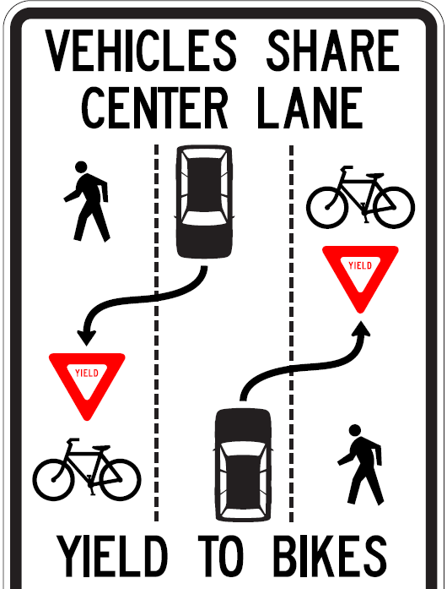
Hanover-style Sign

The questions on signage elicited some facility-specific responses from multi-ELR agencies. This results in the number of agency responses being greater than the number of agencies responding to the survey. This makes it difficult to accurately evaluate findings on a per-agency basis.
No data on the use of No Parking or speed limit signs is included here.

Q: Use of a W6-3 sign?
29 facilities, 8 agencies use a W6-3 sign;
17 facilities, 11 agencies did not use a W6-3 sign;
4 facilities, 4 agencies used no signs whatsoever.
A W6-3 sign is recommended but not required in the FHWA request-to-experiment guidance.

Q: Use of a Bike Lane or Bike Route sign?
26 facilities, 9 agencies use a Bike Lane or Bike Route sign;
20 facilities, 9 agencies did not use a Bike Lane or Bike Route sign;
4 facilities, 4 agencies used no signs whatsoever.
An R3-17 bike lane sign is required in the FHWA request-to-experiment guidance.

Q: Use of a permanent Hanover-style sign?
21 facilities, 10 agencies use a permanent Hanover-style sign;
25 facilities, 8 agencies did not use a permanent Hanover-style sign;
4 facilities, 4 agencies used no signs whatsoever.
Use of any sign describing expected behavior is not addressed in the FHWA request-to-experiment guidance. Agencies with FHWA approval that have inquired about use of such a sign have been denied permission to use it.
Of the 10 agencies that use a permanent Hanover-style sign, 5 are located in the northeastern U.S.

Q: Use of a temporary Hanover-style sign?
7 facilities, 2 agencies use a temporary Hanover-style sign;
39 facilities, 14 agencies did not use a temporary Hanover-style sign;
4 facilities, 4 agencies used no signs whatsoever.
One multi-ELR agency was responsible for all but one of the facilities that used a temporary Hanover-style sign.

Q: “If you do not use a permanent Hanover-style sign illustrating desired behavior, do you believe its absence has resulted in safety problems?”
18 facilities, 9 agencies did not respond to this question;
27 facilities, 9 agencies responded “No”;
5 facilities, 4 agencies responded “Unknown”;
0 facilities, 0 agencies responded “Yes”.
No evidence or research is known that addresses the efficacy of any Hanover-style sign.

Q: “If you do use a permanent Hanover-style sign illustrating desired behavior, do you believe it’s presence has reduced safety problems?”
24 facilities, 6 agencies did not respond to this question;
10 facilities, 10 agencies responded “Unknown”;
4 facilities, 3 agencies responded “Maybe”;
12 facilities, 3 agencies responded “Yes”.
No evidence or research is known that addresses the efficacy of any Hanover-style sign.

Q: “If you do not use a W6-3 sign on this ELR, are clues such as on-street parking present that communicate a two-way condition?”
27 facilities, 7 agencies did not respond to this question;
10 facilities, 9 agencies responded “No”;
3 facilities, 2 agencies responded “Maybe or Sometimes”;
10 facilities, 6 agencies responded “Yes”.
On this question, some multi-ELR agencies provided different responses for their ELRs. The presence or absence of on-street parking is one possible cause for different responses from a multi-ELR agency.

Q: “Do you believe that the need for any signage has decreased over time as drivers have become familiar with the treatment?”
1 facility, 1 agency did not respond;
14 facilities, 8 agencies responded “Unknown”;
13 facilities, 4 agencies responded “No”;
9 facilities, 3 agencies responded “Maybe”;
13 facilities, 8 agencies responded “Yes”.

Unique Signs
One agency responded that they used the W8-12 No Center Line sign on two of their seven facilities. No other agency reported the use of this sign.
One agency responded that they used a Road Narrows sign (presumably a W5-1). No other agency reported use of this sign.

PAVEMENT MARKINGS - SYMBOLS USED IN EDGE LANES
Most, if not all, of the facilities included in this survey support bicyclists. Some facilities are shared use and support bicyclists and pedestrians.

Q:”What pavement symbols are used in the edge lanes of this ELR?”
17 facilities, 4 agencies used “No Symbols”;
1 facility, 1 agency used “Shared Lane Marking”;
1 facility, 1 agency used a custom mural covering the edge lane that incorporates bicycle and pedestrian symbols;
2 facilities, 2 agencies used a combination of pedestrian symbols and bicyclist symbols;
the remainder used bicycle symbols or a combination of symbols e.g. helmeted bicyclist, bicycle, shared lane marking.

Q: “Do you believe that the need for any pavement markings has decreased over time as drivers have become familiar with the treatment?”
11 facilities, 5 agencies responded “Yes”;
13 facilities, 7 agencies responded “Unknown”;
the remainder responded “No”.
This question is problematic. It was intended to only ask about the pavement symbols used in the edge lanes but the wording used was “pavement markings”, raising questions about what the respondents had in mind when answering. It is known that some respondents interpreted “pavement markings” as including the broken lines separating the center lane from the edge lanes.

PAVEMENT MARKINGS - USE OF COLOR
Q: “Is color used on this ELR?”
3 facilities, 2 agencies used color entirely in the edge lane;
1 facility, 1 agency used color to mark a path through an intersection.
the remainder used no color on their facilities.

PAVEMENT MARKINGS - USE OF CENTER LANE SYMBOL
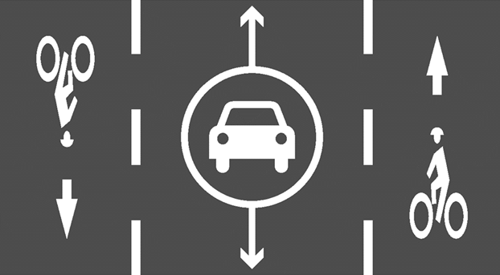

Q: “Do you believe a pavement marking in the center lane indicating 2-way traffic would help unfamiliar drivers?”
11 facilities, 6 agencies responded “Unknown”;
9 facilities, 6 agencies responded “Maybe”;
3 facilities, 3 agencies responded “Yes”;
27 facilities, 8 agencies responded “No”.
This question is problematic. Some agencies may answer this question assuming the symbol would be supplemental to the signs they currently use while others may answer this question assuming the symbol would be provided as a substitute for signage (the latter was the intention of the question).

Discussion of Results
SAFETY
Available research, the responses provided in this survey, and the success of facilities installed over the last 13 years all support the claim that edge lane roads are safe and that they may be safer than their two-lane counterparts.

W6-3 SIGN
29 facilities and 8 agencies use a W6-3 sign while 21 facilities and 15 agencies don’t. Experience with early ELRs (http://altaplanning.com/resources/advisory-bike-lanes-north-america/) indicates that communicating the two-way nature of an ELR is necessary and likely sufficient. This position appears to be supported by the safety of facilities that do not use a Hanover-style sign or that use no signs at all. A W6-3 sign conveys an ELR’s two-way nature but may not be necessary if other clues, such as on-street parking or short segments of centerline at intersections exist. It may not be necessary if volumes or speeds are so low that problematic encounters are unlikely. Consideration of W6-3 signs, as the FHWA recommends, appears to be effective guidance.

BIKE LANE/BIKE ROUTE SIGNS
26 facilities and 9 agencies use a Bike Lane/Route sign while 24 facilities and 13 agencies don’t. Use of bicycle symbols in the edge lanes likely reduces the need for Bike Lane/Route signs as they do on standard bicycle lanes. ELRs with higher vulnerable road user volumes and a high percentage of repeat drivers are also likely to have a smaller need for Bike Lane/Route signs. Depending on state law, the presence of Bike Lane/Route signs and/or symbols may legally designate the edge lanes as bicycle lanes thus excluding motor vehicles and pedestrians from the edge lanes. Consideration of Bike Lane/Route signs in the context of the types of vulnerable road users being accommodated, traffic characteristics, and applicable state law appears to be effective guidance. Current FHWA request-to-experiment guidance only addresses the use of this treatment for bicycles and requires an R3-17 sign.

HANOVER-STYLE SIGN - PERMANENT
21 facilities and 10 agencies use a permanent Hanover-style sign while 29 facilities and 12 agencies don’t. Five of the ten agencies that use these signs can arguably be viewed as a single agency because many of their designs came from one person or were adopted from nearby installations. From interviews with agency representatives, it is concern about the impact of unfamiliar drivers that drives the use of the Hanover-style sign. No evidence exists on the benefits of this sign. One can point to the safety record of the many installations that forgo this sign to justify not using it.
When agencies that used this sign were asked whether this sign provided safety benefits, 13 agencies responded with “Unknown” and “Maybe”. Only 3 agencies responded with a positive “Yes”. Similarly, none of the agencies without these signs were concerned about safety issues resulting from their absence. These responses may be the result of confirmation bias and/or a lack of data but they fail to provide a strongly positive recommendation.

HANOVER-STYLE SIGN - TEMPORARY
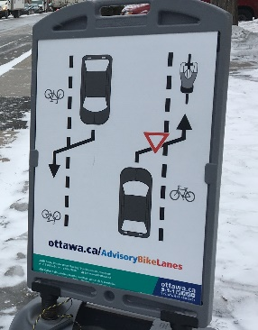
The use of a temporary, large format Hanover-style sign on a facility for some time following its installation is a new practice that was first employed in Canada (see image below). Use of a temporary Hanover-style sign may be useful on facilities with lower volumes of new drivers. Temporary signage could establish a pattern of use that sustains itself and educates later, unfamiliar drivers as they observe and interact with other road users. No data exists on the effectiveness of this strategy. One multi-ELR agency uses this strategy often and considers it successful. Wider use of this strategy would provide more information on its usefulness.

SIGN USE OVER TIME
No data exists on whether the need for signage decreases as familiarity with the treatment grows. One would suspect, as approximately half of the responding agencies do, that the need for signage would drop over time, especially on facilities with high percentages of repeat drivers. One parallel is the decreasing use of signage on two-way left-turn lanes (TWLTLs). TWLTLs are an example of a widely used two-way, single-lane treatment that sometimes requires opposite-direction drivers to use the same real estate. Decreased signage use on TWLTLs is discussed in a pre-print article found at https://www.advisorybikelanes.com/uploads/1/0/5/7/105743465/what_two-way_left-turn_lanes_teach_us_about_edge_lane_roads.pdf.
Given the concerns about unfamiliar drivers, the uncertain comprehensibility of Hanover-style signs, and the substantial percentage of drivers that miss seeing signs, one alternative to signage is pavement markings that indicate preferred road user position and the two-way nature of the roadway (see the question on the center lane symbol). This approach has been seen on German ELRs. No data exists on this approach and no U.S. ELR is known with these pavement markings.

SYMBOL USE IN EDGE LANES
With regards to symbol usage in the edge lanes, 17 facilities and 4 agencies left the edge lanes completely unmarked. These unmarked ELRs consisted of low volume facilities (<1,000 ADT) or facilities used in a small city with many other installations (and an assumed higher level of familiarity). Three facilities and 3 agencies use a combination of pedestrian and bicycle symbols reflecting the shared use nature of their facilities. The remaining respondents used one or a combination of shared lane markings, helmeted bicyclist symbol, or bicycle symbols. No facilities or agencies used the word legend “Bike Lane”.
It seems likely that lower volume ELRs and/or ELRs with high rates of repeat users would perform well without edge lane symbols. Use of symbols reflecting the vulnerable road users expected in the edge lanes helps convey the preferred location of each road user type. Current FHWA request-to-experiment guidance only addresses ELRs as a bicycle facility and requires use of bicycle lane symbols. No guidance is provided for shared use or pedestrian-only ELRs. Consideration of edge lane symbols that include non-bicycle symbols would support the use of ELRs for all types of vulnerable road users. Unmarked edge lanes may be appropriate for some ELRs.

USE OF COLOR
With regards to color, only 3 facilities under 2 agencies are known to use color in the entirety of the edge lanes; all of them responded to this survey. An additional agency used color as a skip treatment through an intersection. One agency replaced door-zone bike lanes on a two-lane street with an ELR featuring green edge lanes. The agency conducted a 3-stage informal assessment using intercept surveys of bicyclists. Surveys were conducted while the standard bike lanes were present, after the uncolored ELR had been installed, and after the coloring of the edge lanes. Each survey garnered a bit more than 20 responses. Questions asked respondents to rate their comfort, whether passing drivers provided adequate space for them, and whether they felt that drivers were aware of them. The ratings for all questions went up at each stage indicating greater comfort on an ELR than on door-zone bike lanes and greater comfort on an ELR with colored edge lanes than on an uncolored ELR. More detail on this survey is available upon request.
Some engineers with first-hand knowledge of this treatment advocate for colored edge lanes. In their opinion, the color provides simple, clear communication of the intent of the facility and desired behavior. The Dutch, who originated this treatment, often use color to mark their edge lanes. Except for the 3 facilities noted, all American ELRs are installed without color. The FHWA request-to-experiment guidance recommends against use of color except for mixing/weaving locations and/or as a background conspicuity enhancement. No data is available on the safety outcomes of color. Experimentation with color is a reasonable and easily justified progression for this treatment.

Acknowledgements
I wanted to thank all of the agencies and people that took the time to respond to this survey. This information is important as regulatory agencies strive to learn about this treatment and effective strategies supporting its use.

Further Information
Questions can be directed to me at bikepedx@gmail.com. More information on the edge lane road treatment is available at www.edgelaneroads.com.

